# MAEG 5720 Computer Vision in Practice

# HW4

XIA, Lei 1155169110

Dr. Terry Chang

December 20, 2021

## Question 1(b)

When conditioning the fundamental matrix to rank 2, the epipolar lines would intersect at one point shown in the Fig. 1, which is the epipole. Otherwise, the epipolar lines would not intersect at one point shown as the Fig. 2.

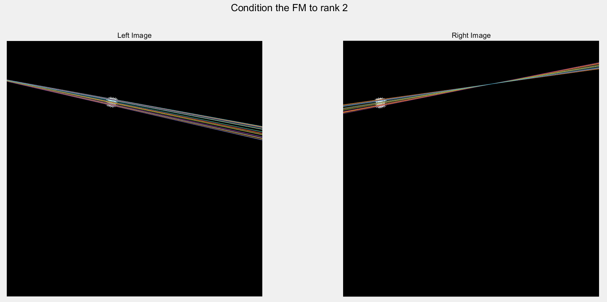

Fig.

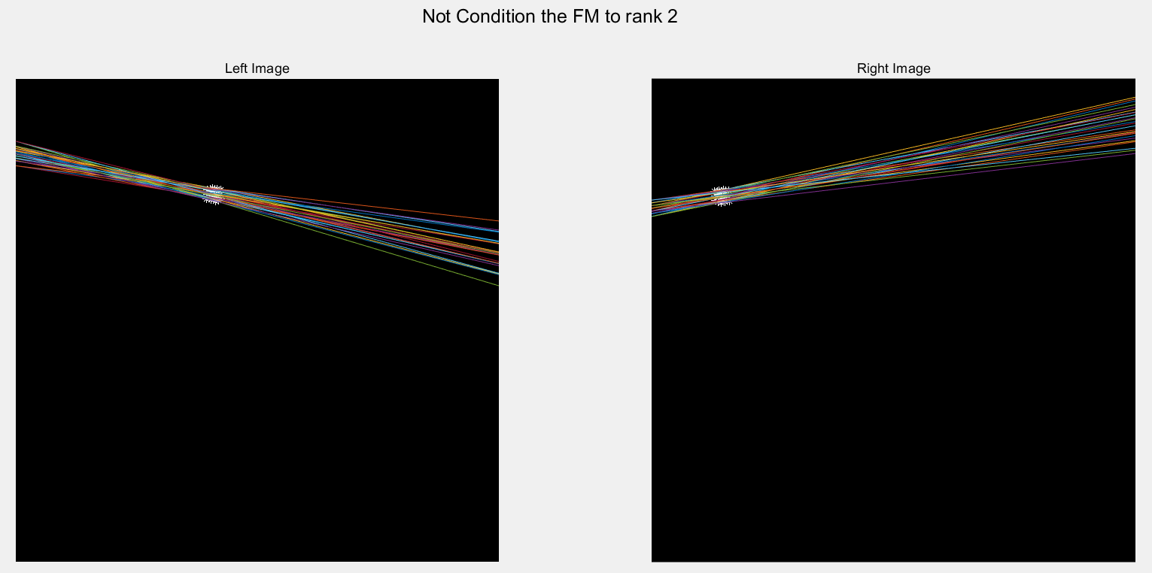

Fig.

## Question 1(c)

The green points are the null space of $F$ or $F^{T}$, which are the intersection of epipolar lines shown as the following picture. This shows that the epipoles are equal to the null space of or .

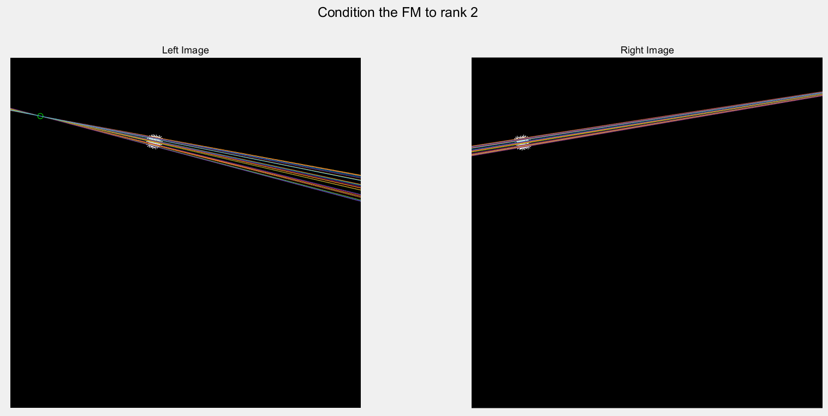

Fig.

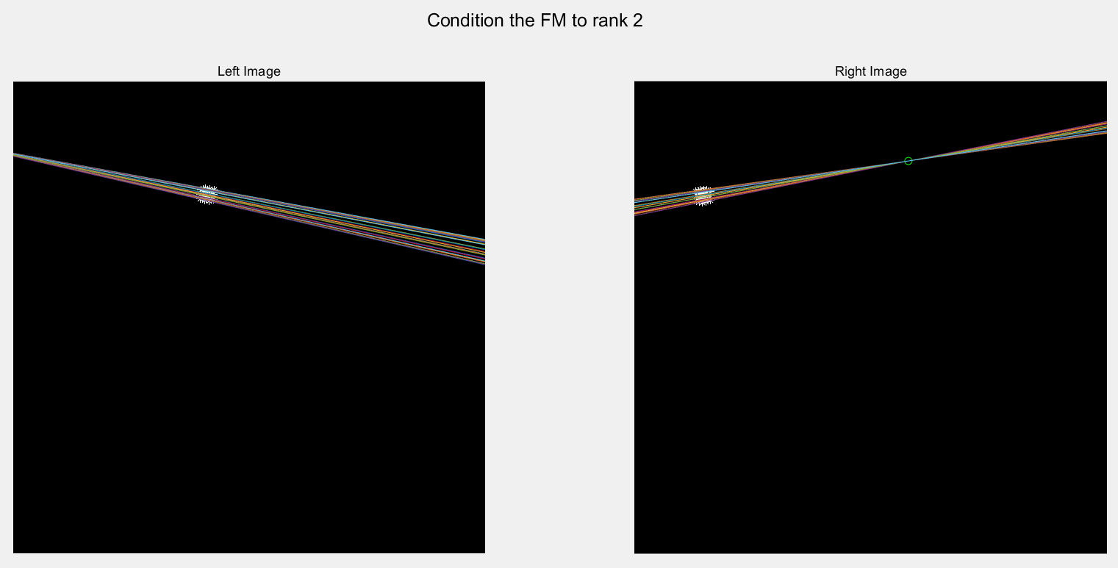

Fig.

## Discussion about normalization process

With normalization, when noises are added, the epipolar lines would still traverse the projective points shown in the Fig. 5. Without normalization, when noises are added, the calculated epipolar lines would be wrong.

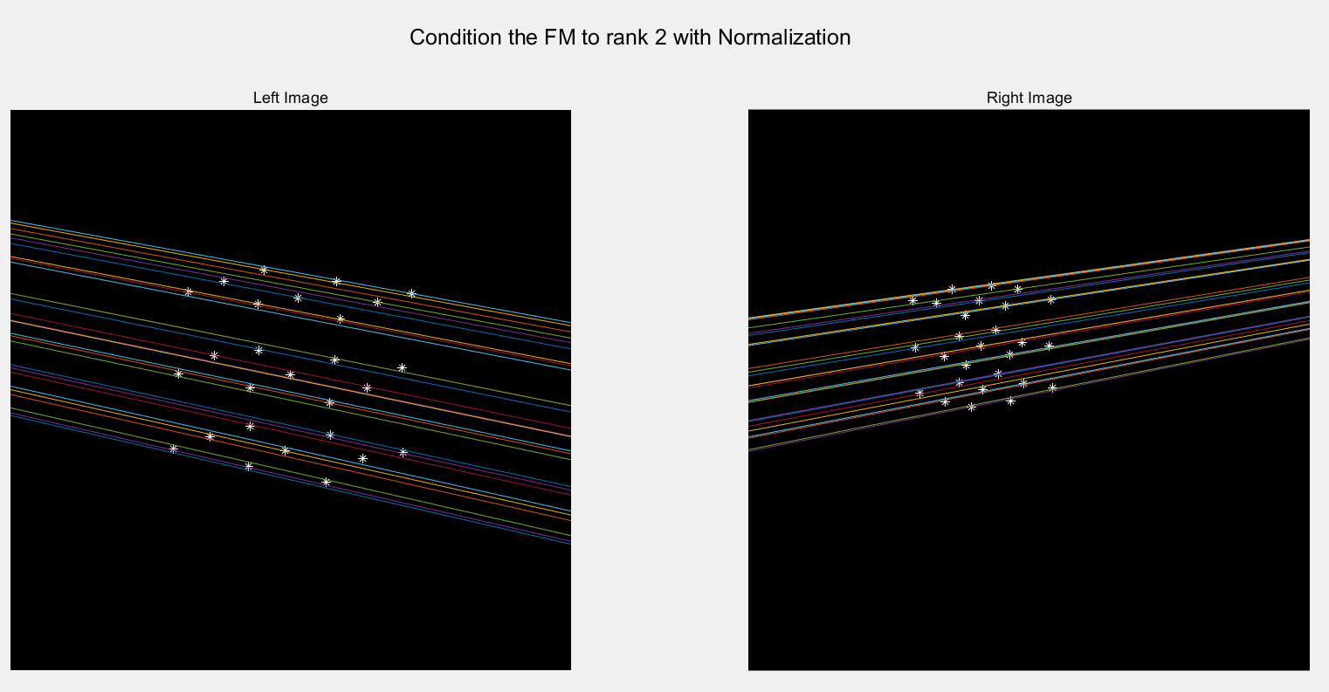

Fig.

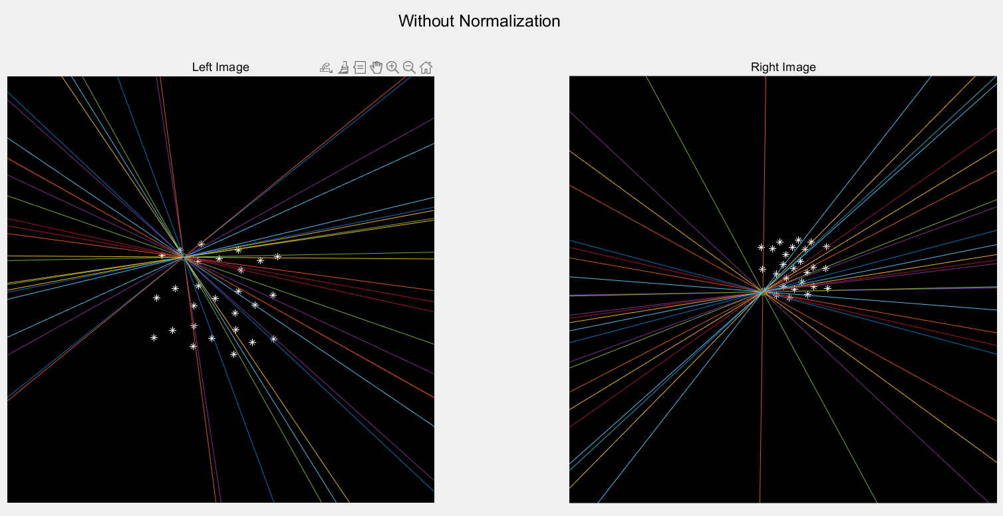

Fig.